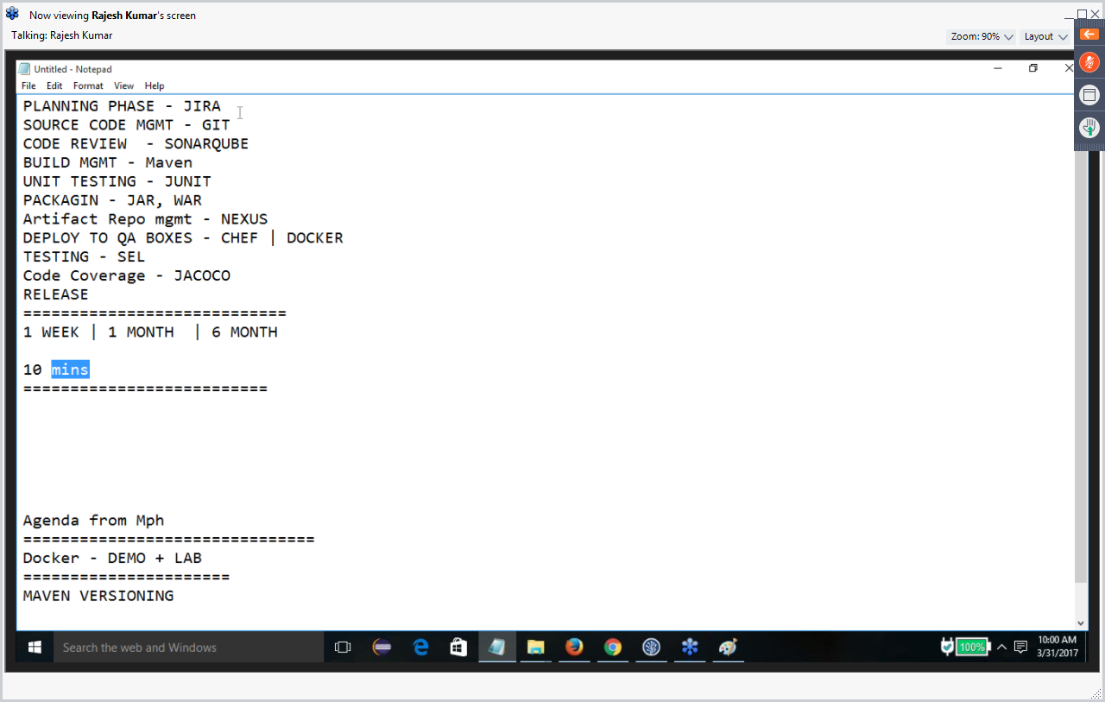

Create amazon account. Aws account

Putty / Login as Root on Linux /

www.Devopsschool.com – Check for docker installation instructions. –Tutorials, Docker

$ sudo yum update – Updates the system. Takes like 2 mins.

Install the docker

$

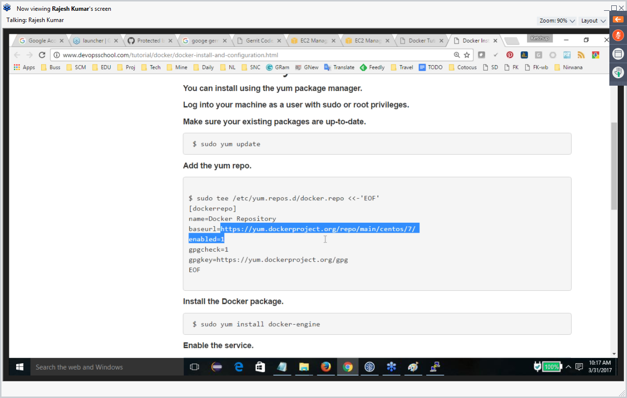

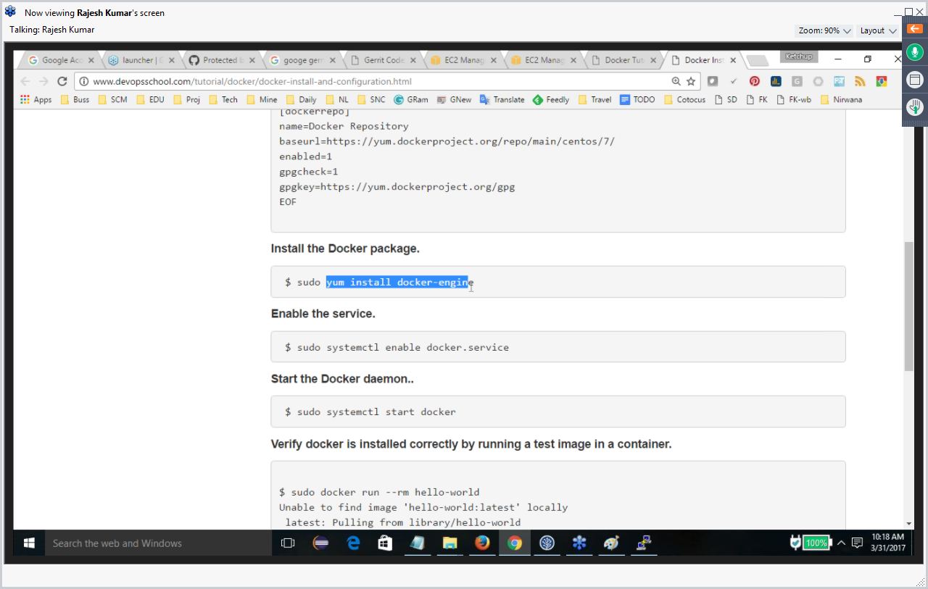

<https://Hub.docker.com> 🡪 Search for JIRA – and see more Starts and Pulls.

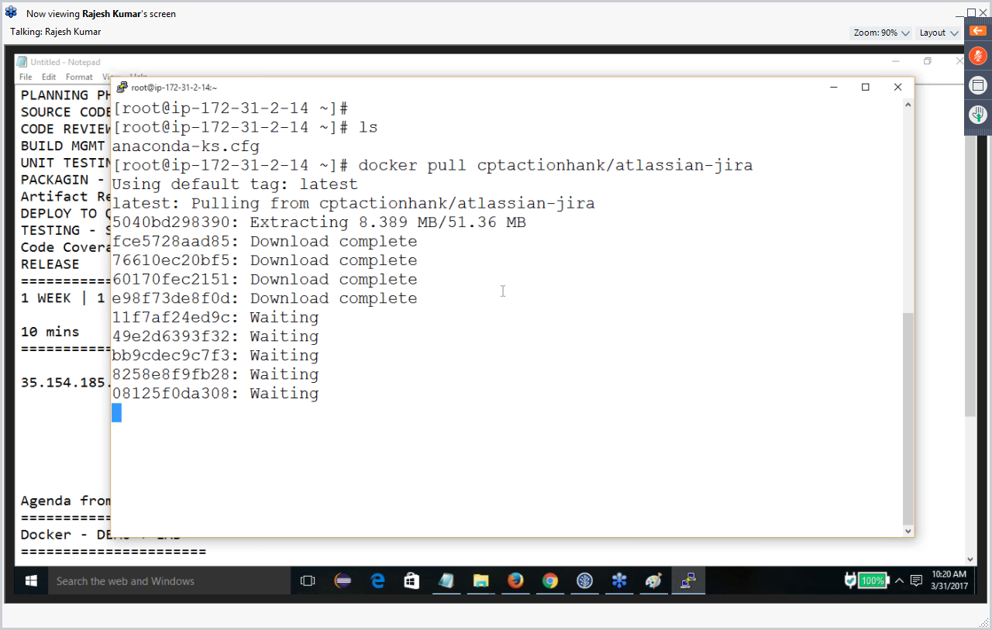

First Get the image and then run dociker

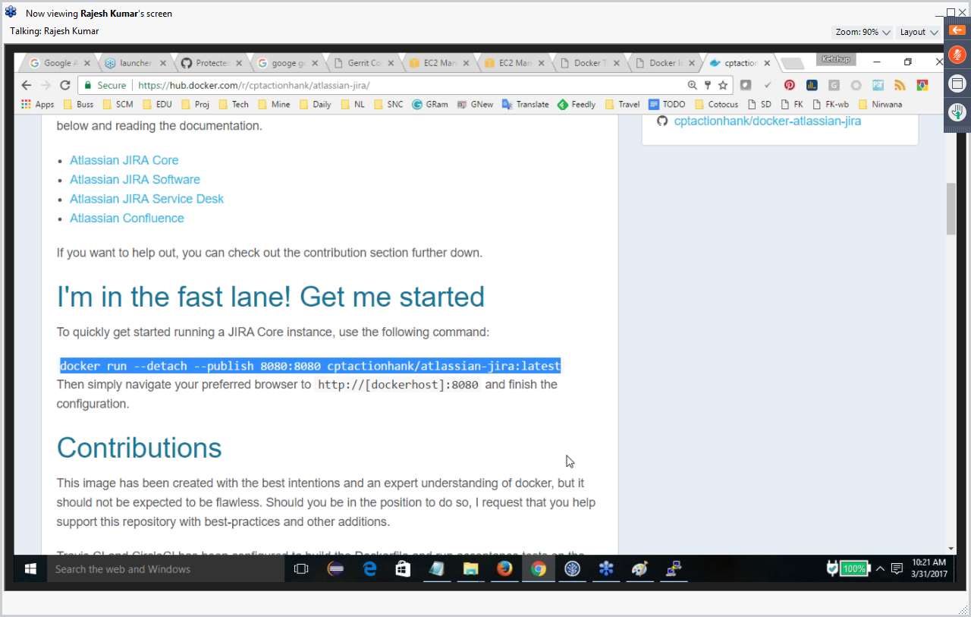

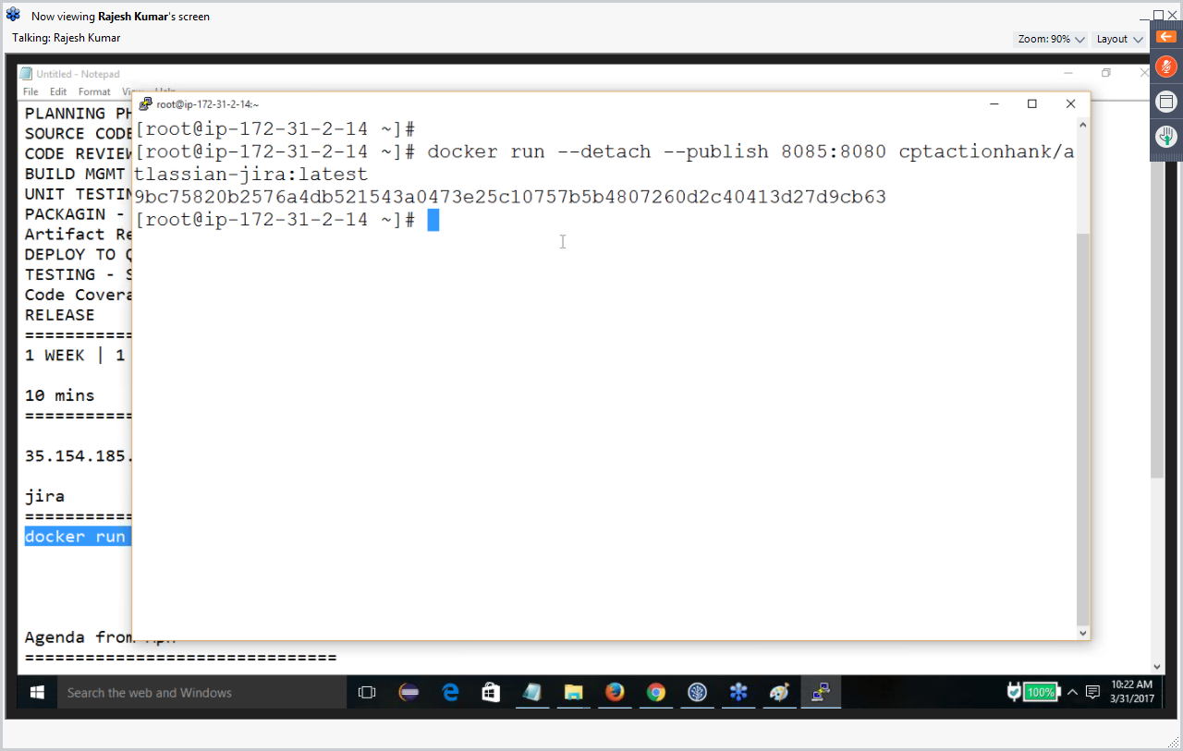

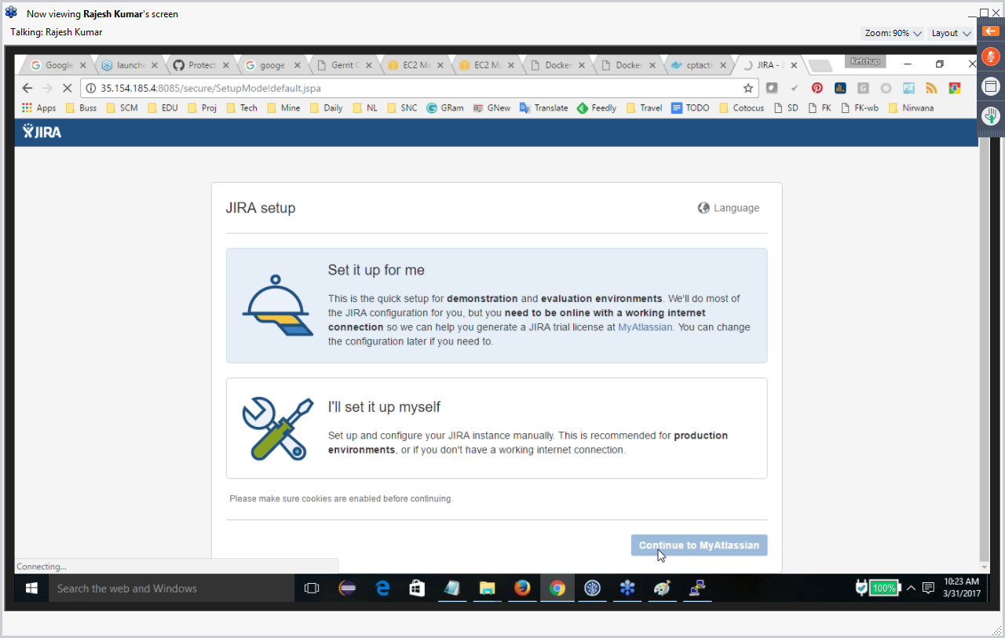

Get a trial license from JIRA

Configure

Create Project management.

And Create Issue and Assign to me

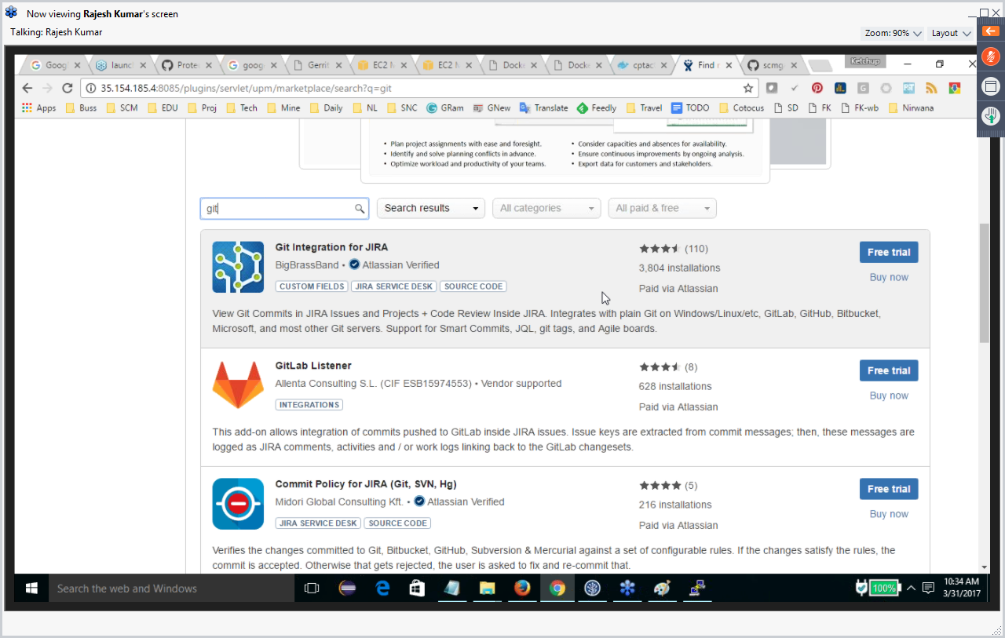

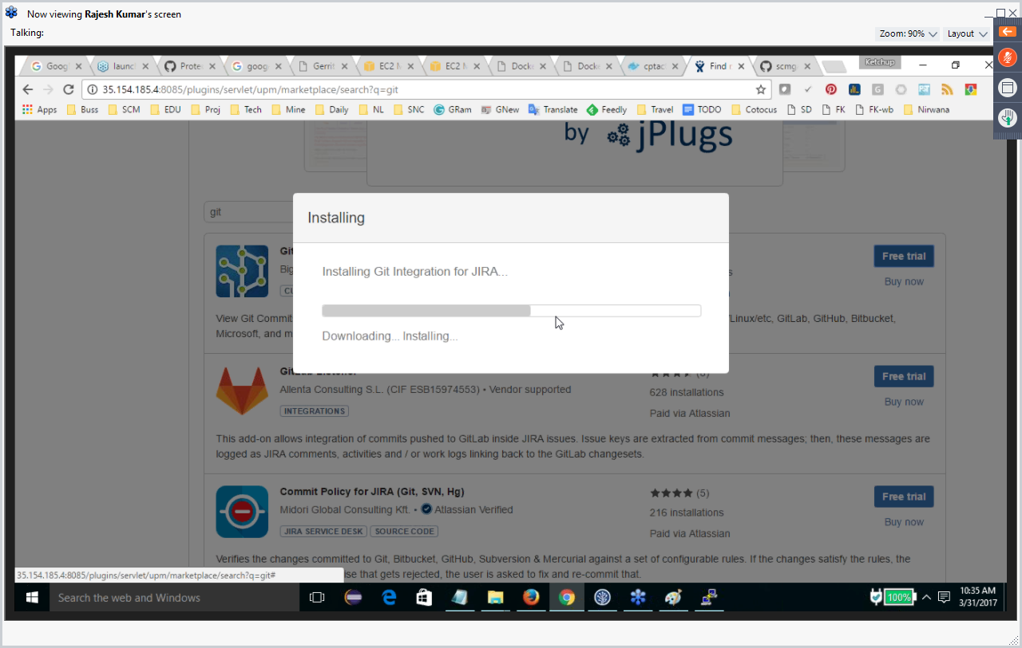

Addons on JirA

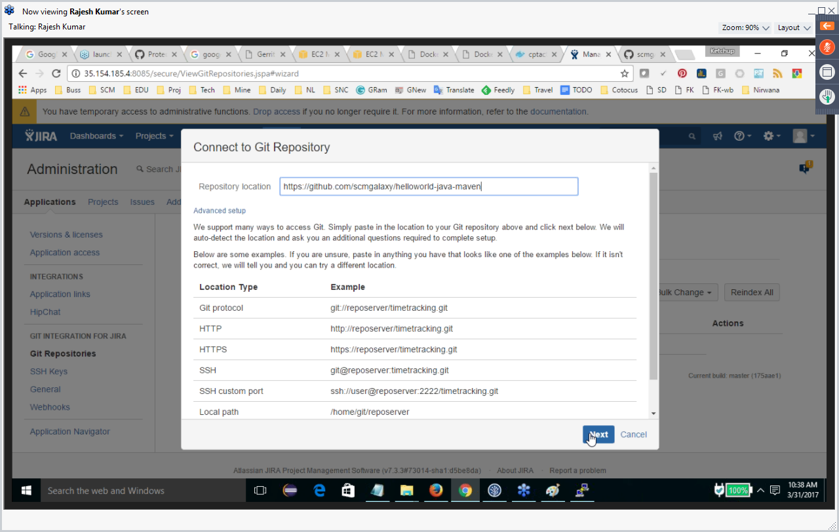

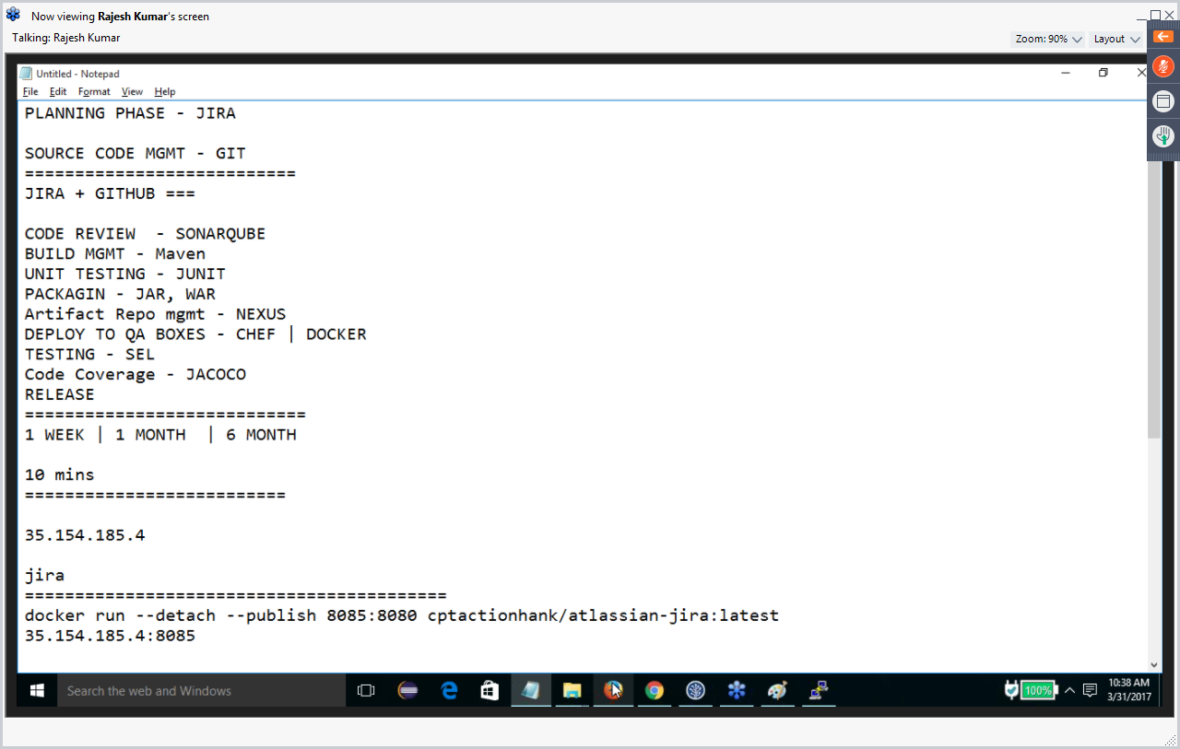

While comitting in GIT make sure to put Key name of JIRA issue.

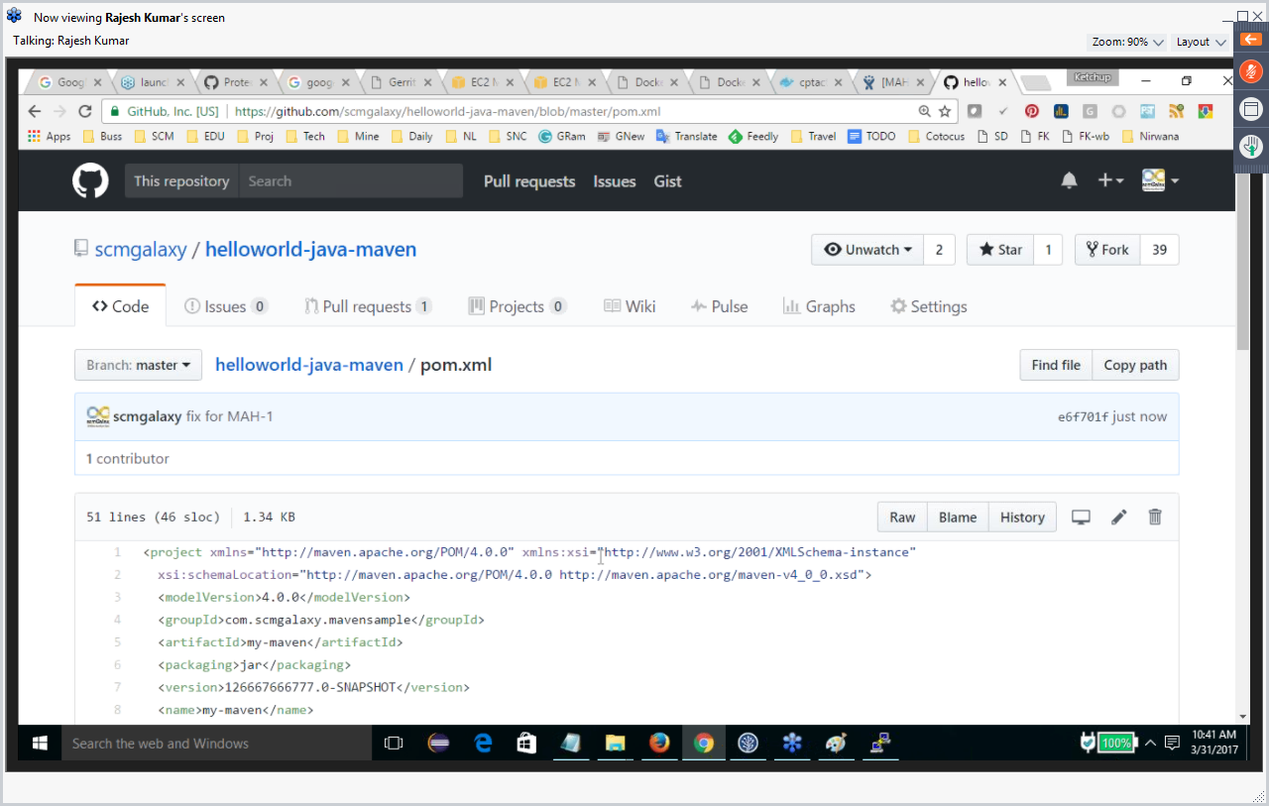

Modify code in JIRA

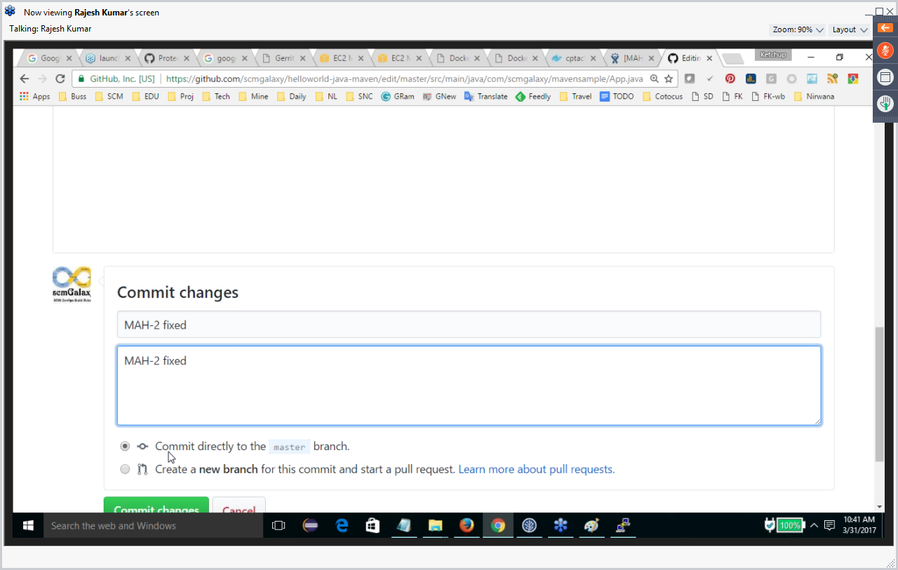

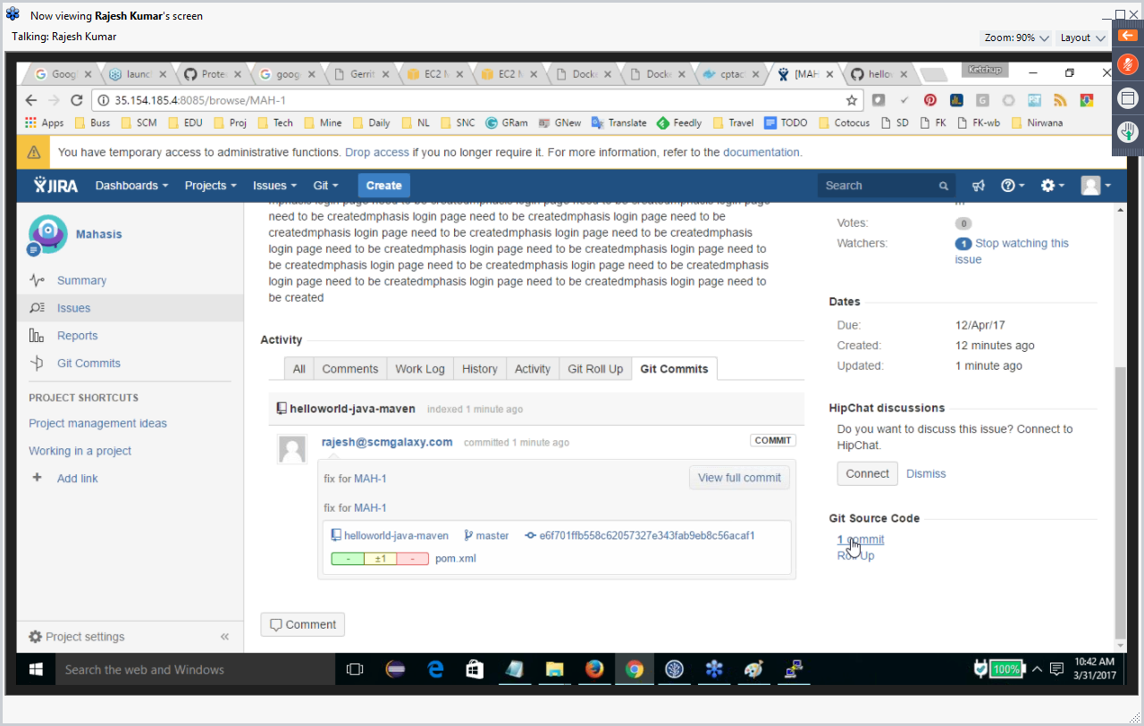

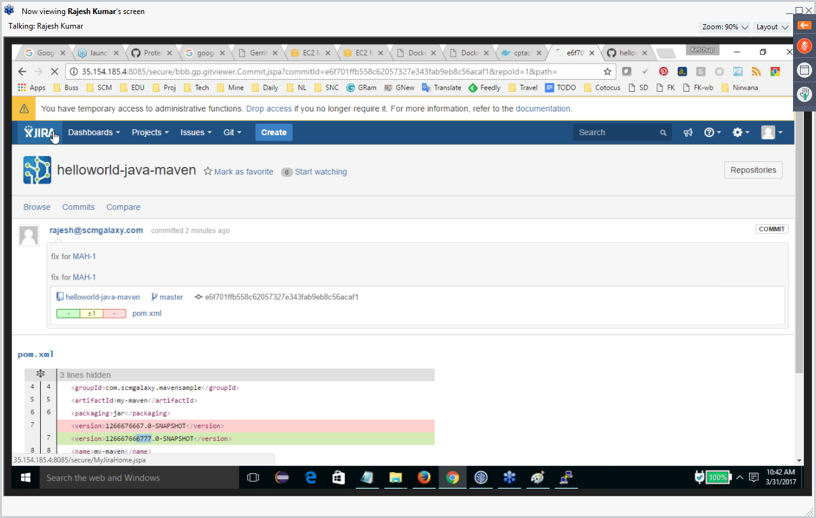

If commits are not shown in JIRA then we can do manual “Reset index” from Add Ons. Only admin can do it. Else after the commit based on what time is set it will update the JIRA with GIT commits.

Setup SonarQube the dockerway and save time. Got

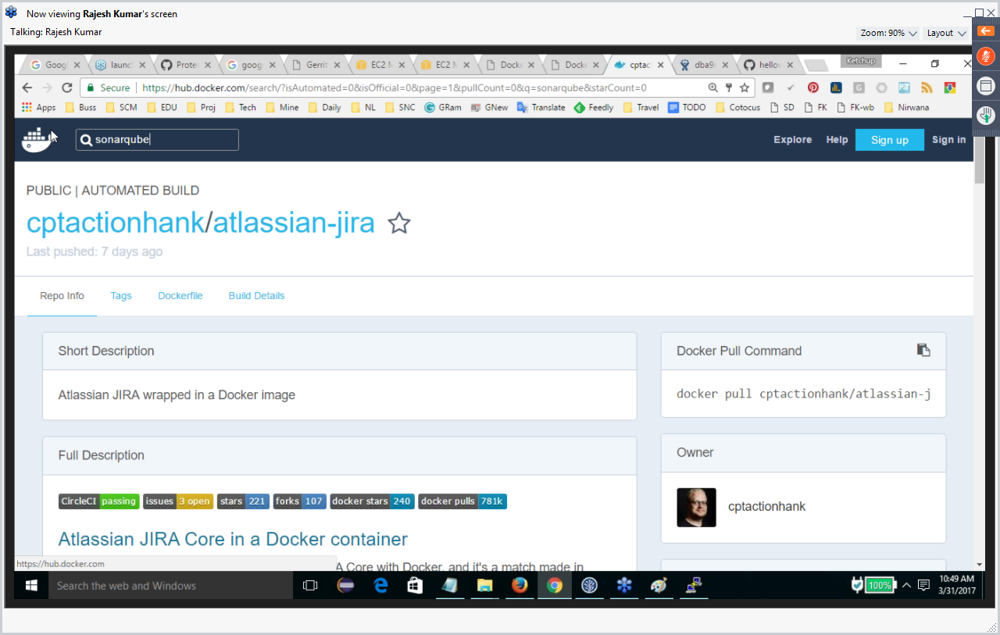

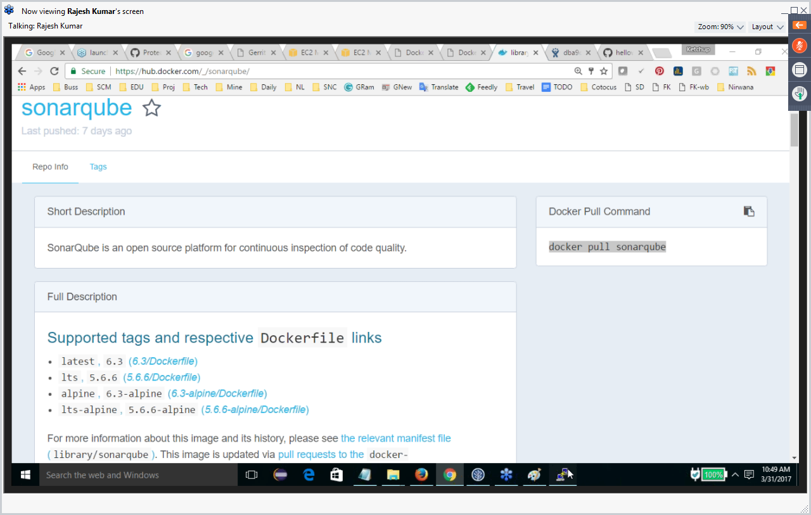

Login to Linux

$ Sudo –s

$ Docker pull sonarqube

How many containers are running in docker

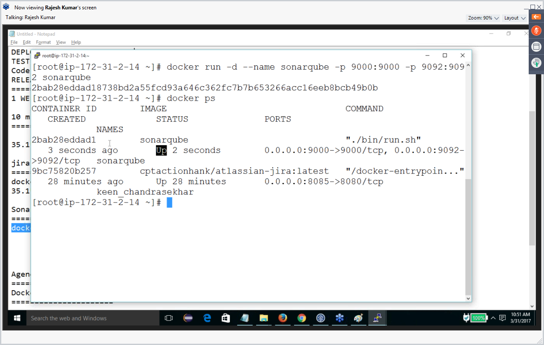

SonarQube Server –Done

Source code –Done

Scanner—Done

Download Nexus via docke

Check how many docker image are there

Run the Nexus image

$ Docker ps – to show if nexus is running.

Login to nexus

Create repository snapshot and release repos. Ex: mphsnapshot and mphrelease. Take the URLs

Add snapshot and release repos URLs in POM.xml and settings.xml (id=deployment, username=, password=).

Setup Jenkins and Java

Download the java

Install wget 🡪Yum wget install

TAR GZ

Export java home and path in the linux system.

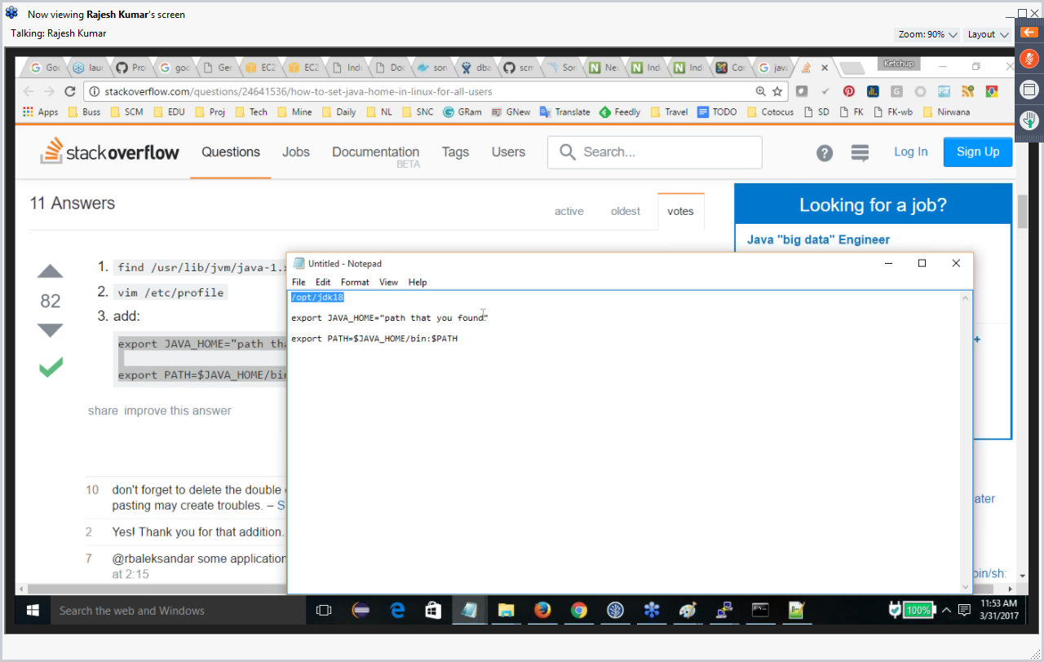

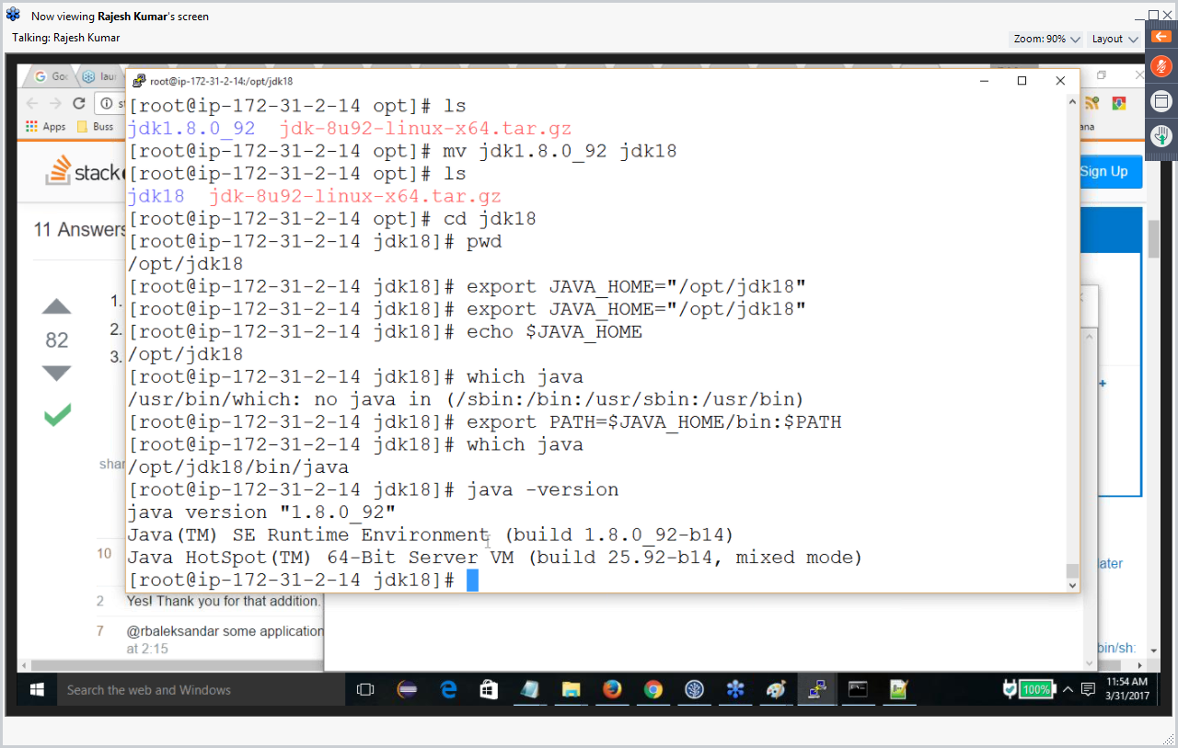

Install Jenkins

https://jenkins.io

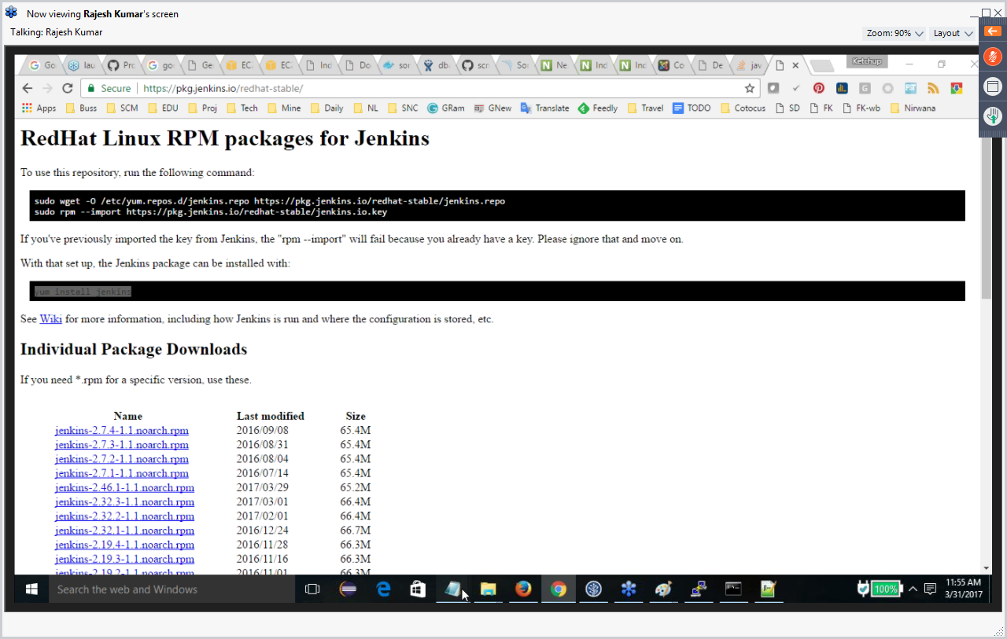

$systemctl start Jenkins

Yum remove Jenkins

$yum install git

**CD**

Manage.chef.io

CHEF SERVER - done

KNIFE CONFIG

COOKBOOKS

NODES – Create node with Amazon

Knife cookbook create web

Knife cookbook upload web

Yum install tree

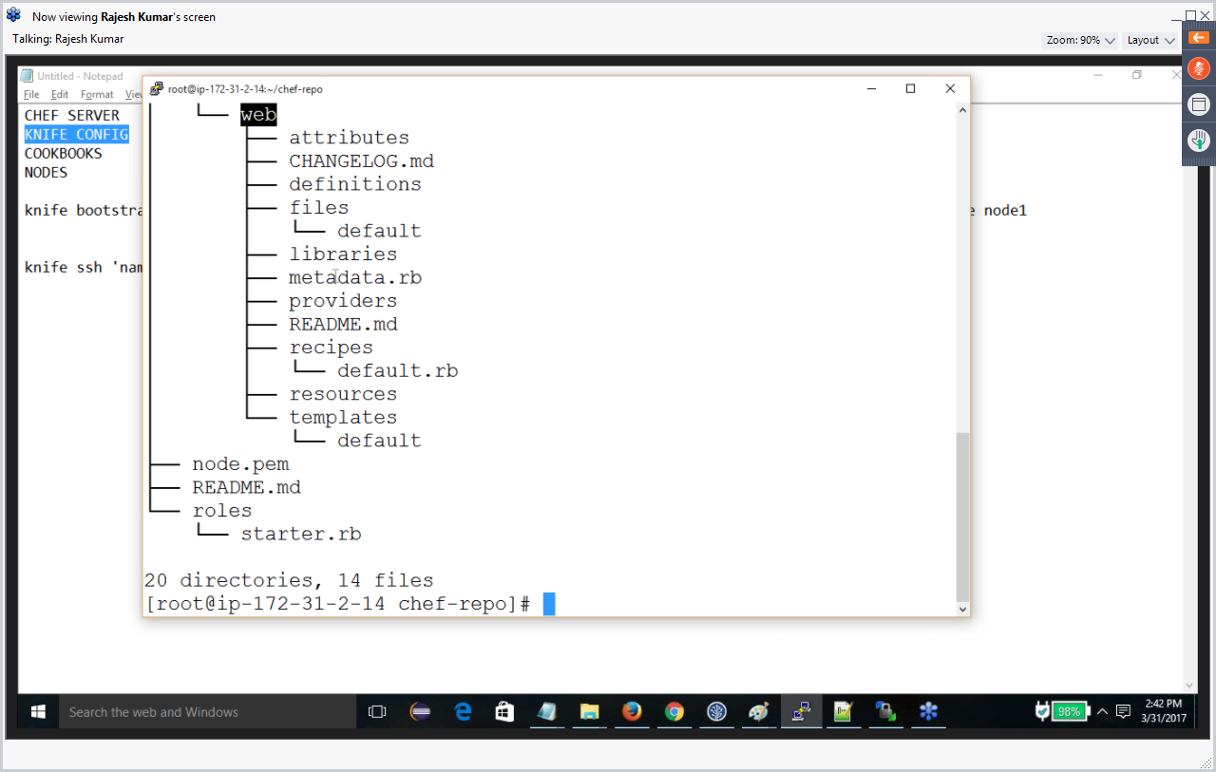

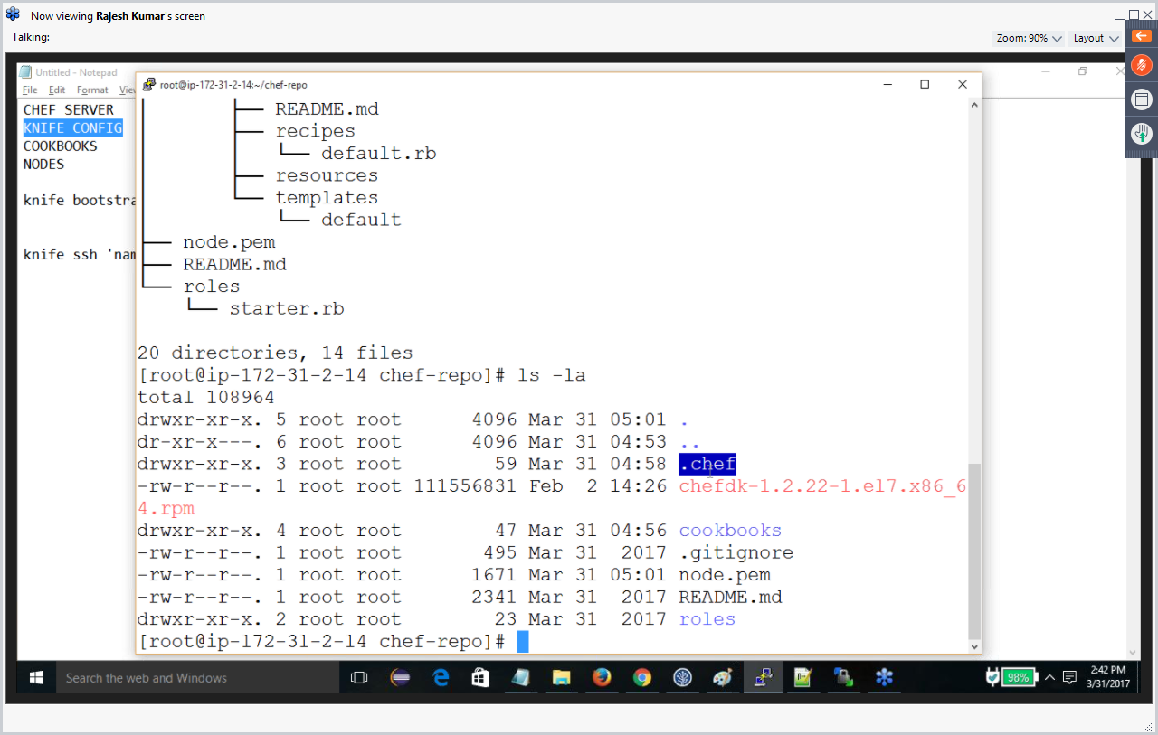

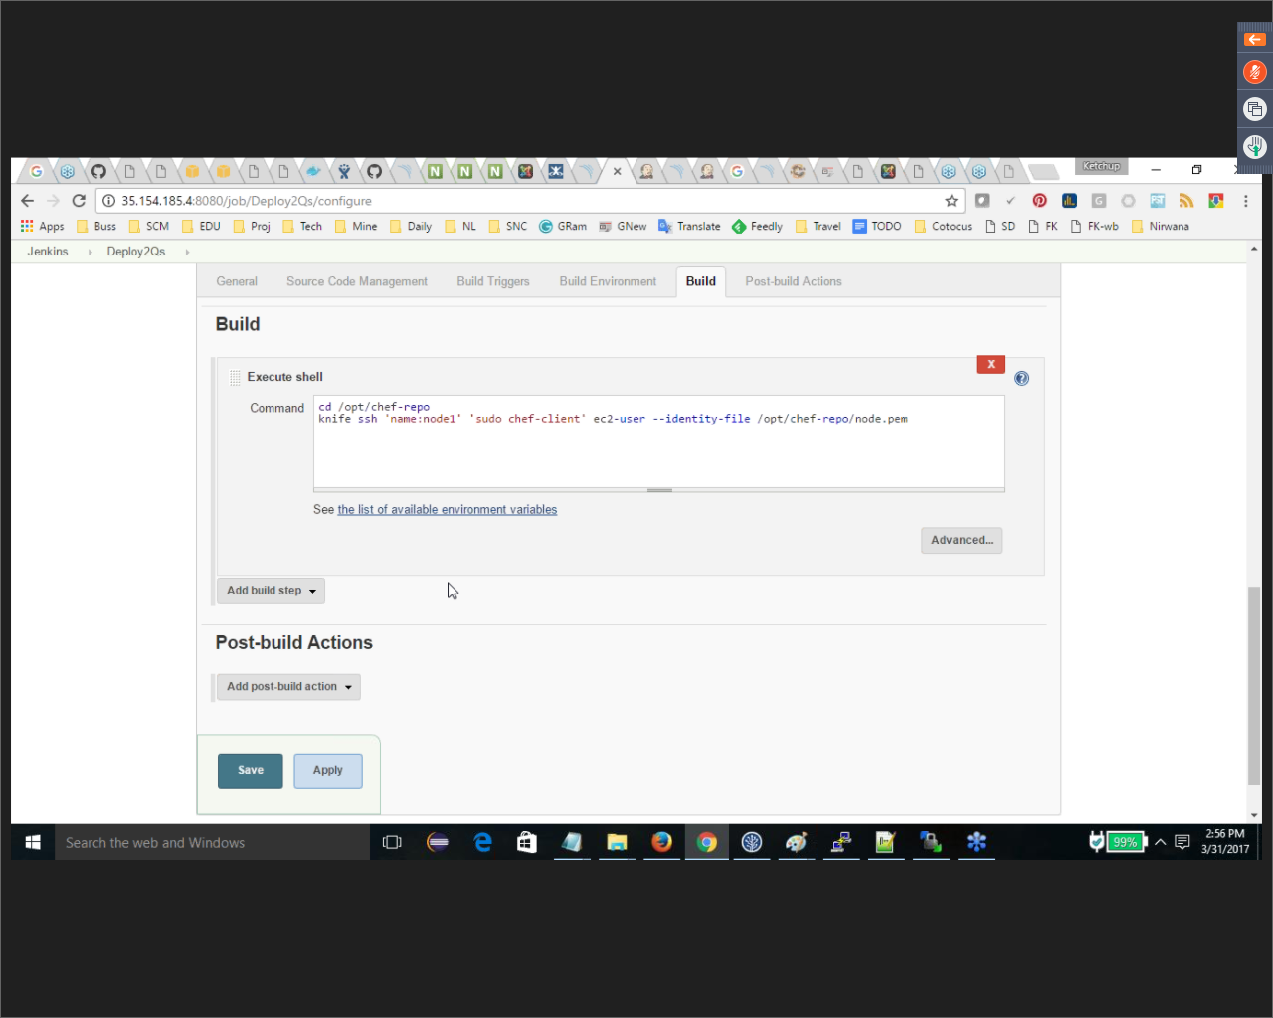

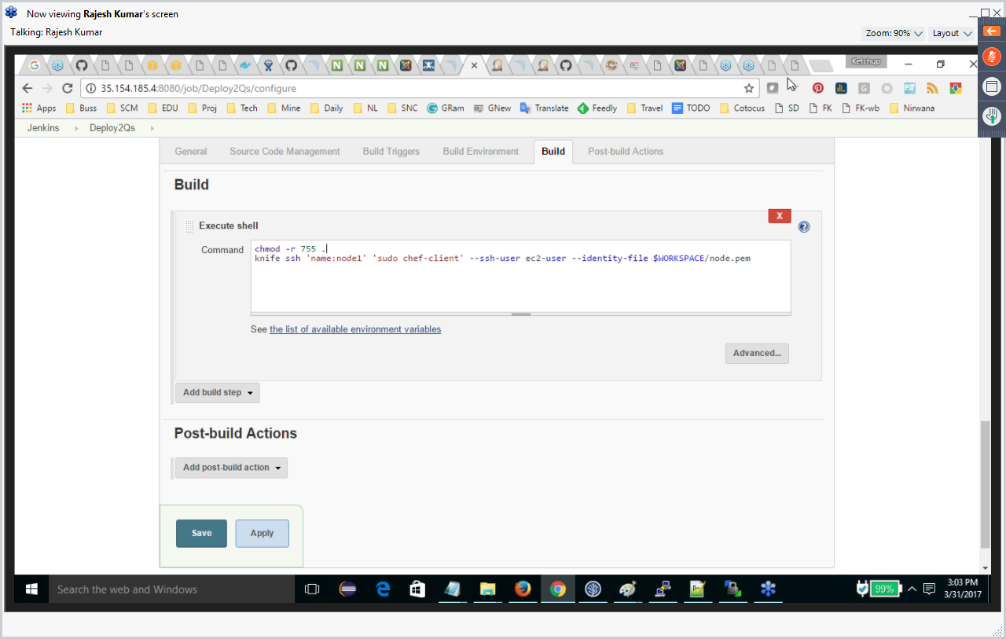

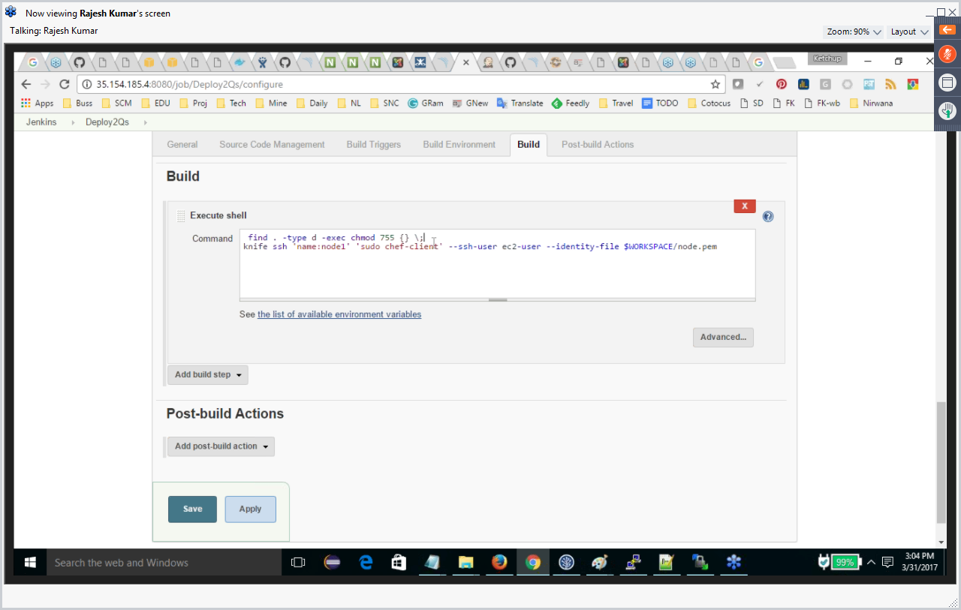

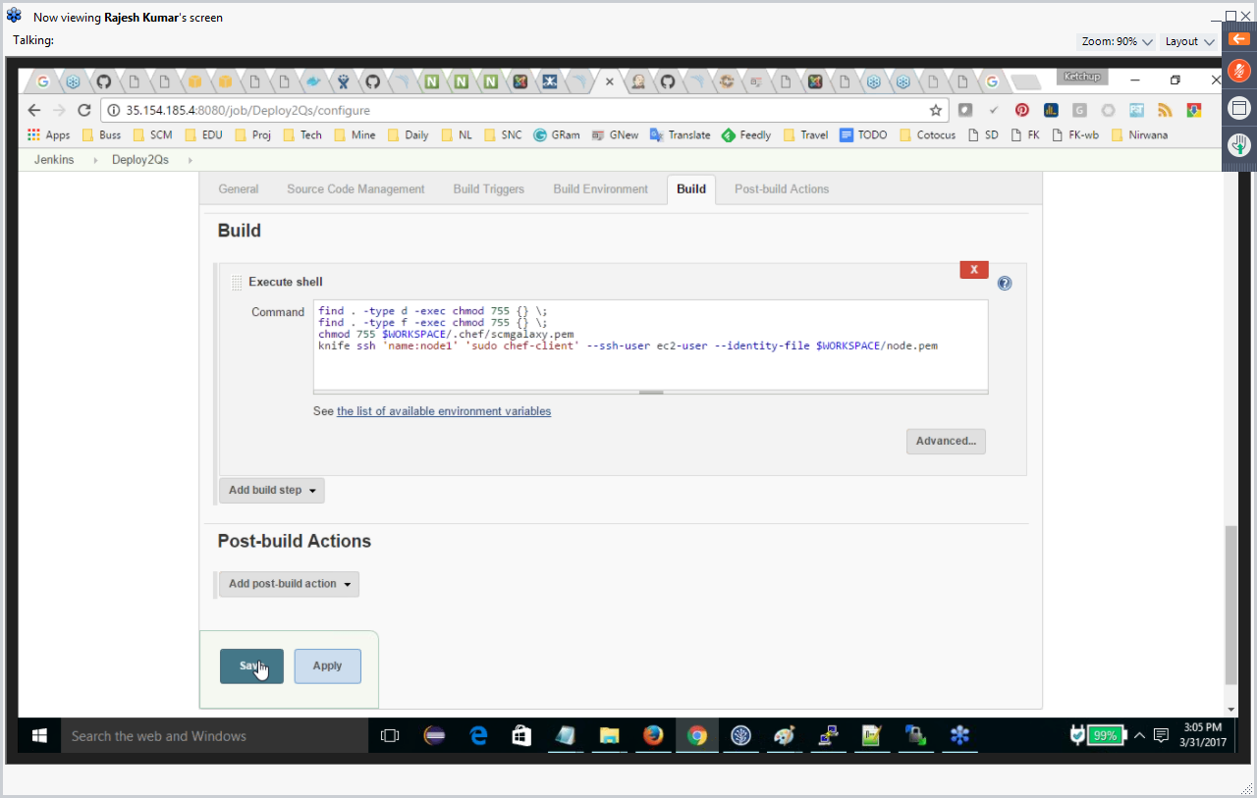

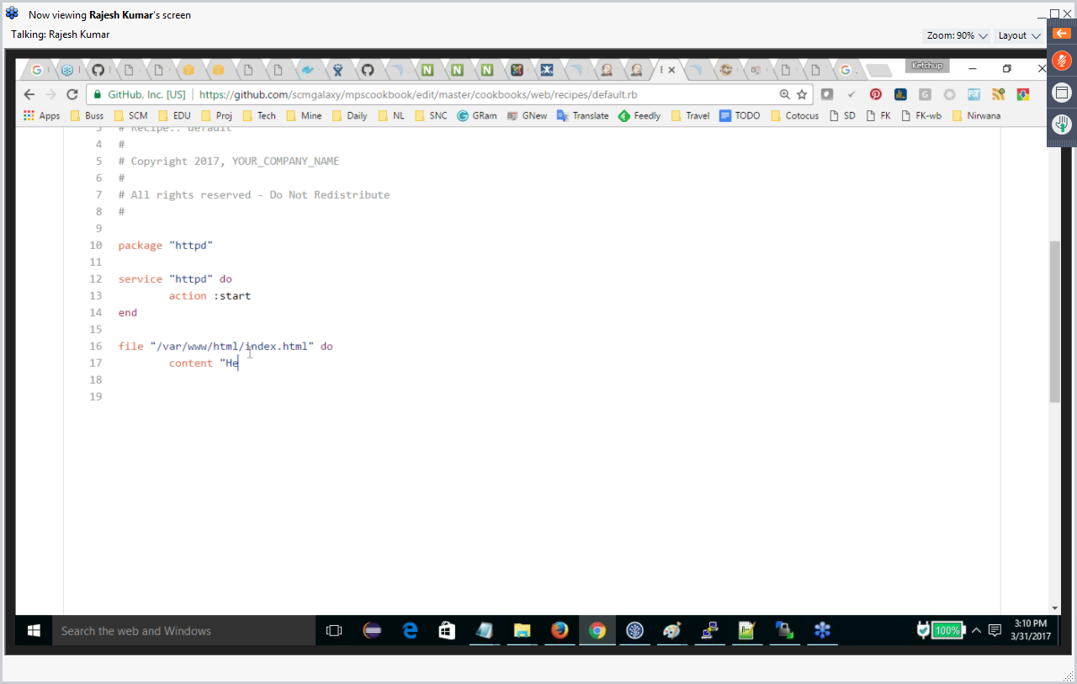

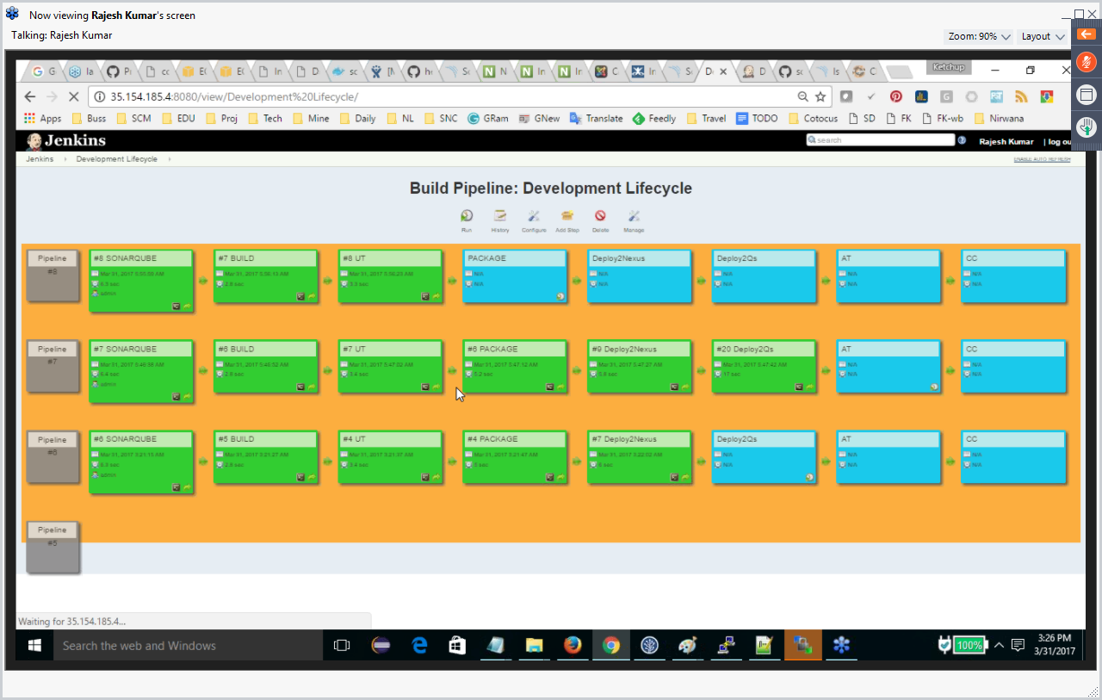

**DOCKER**

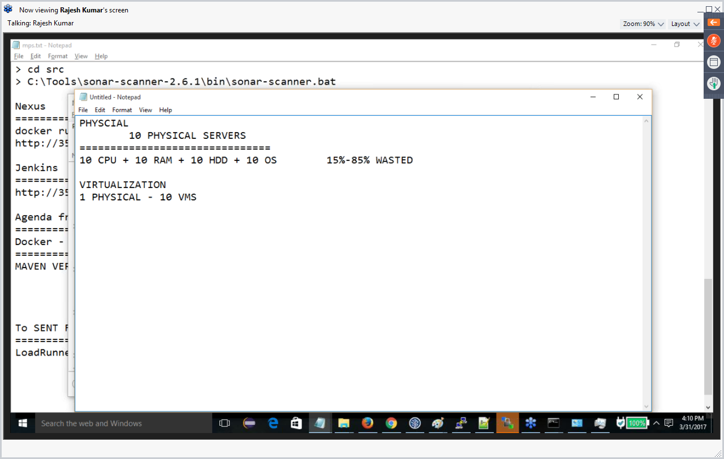

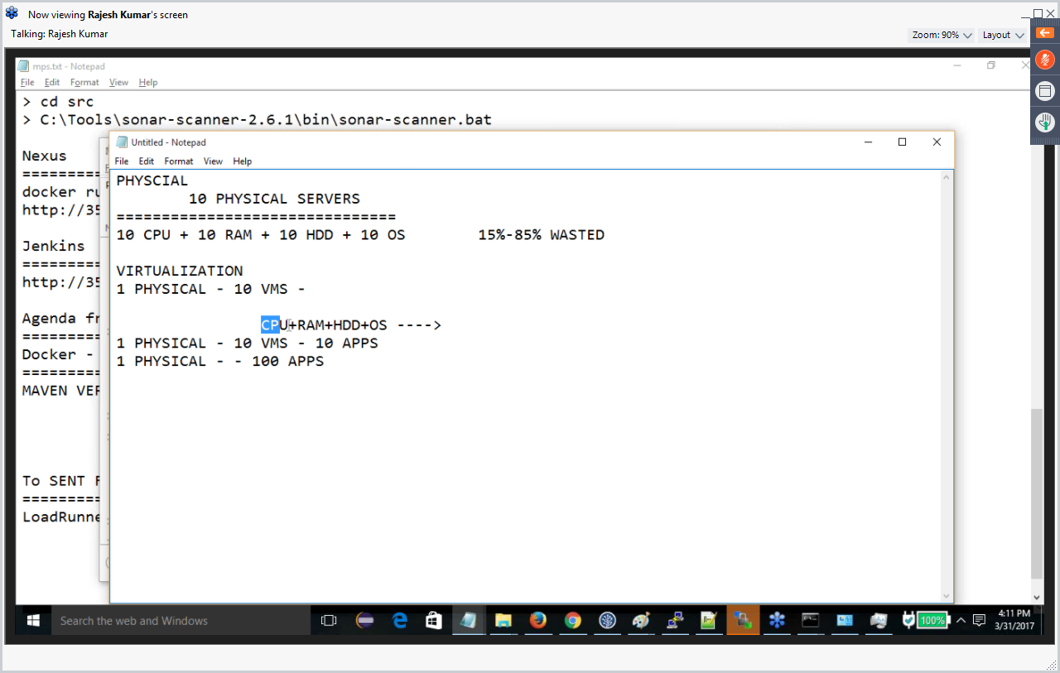

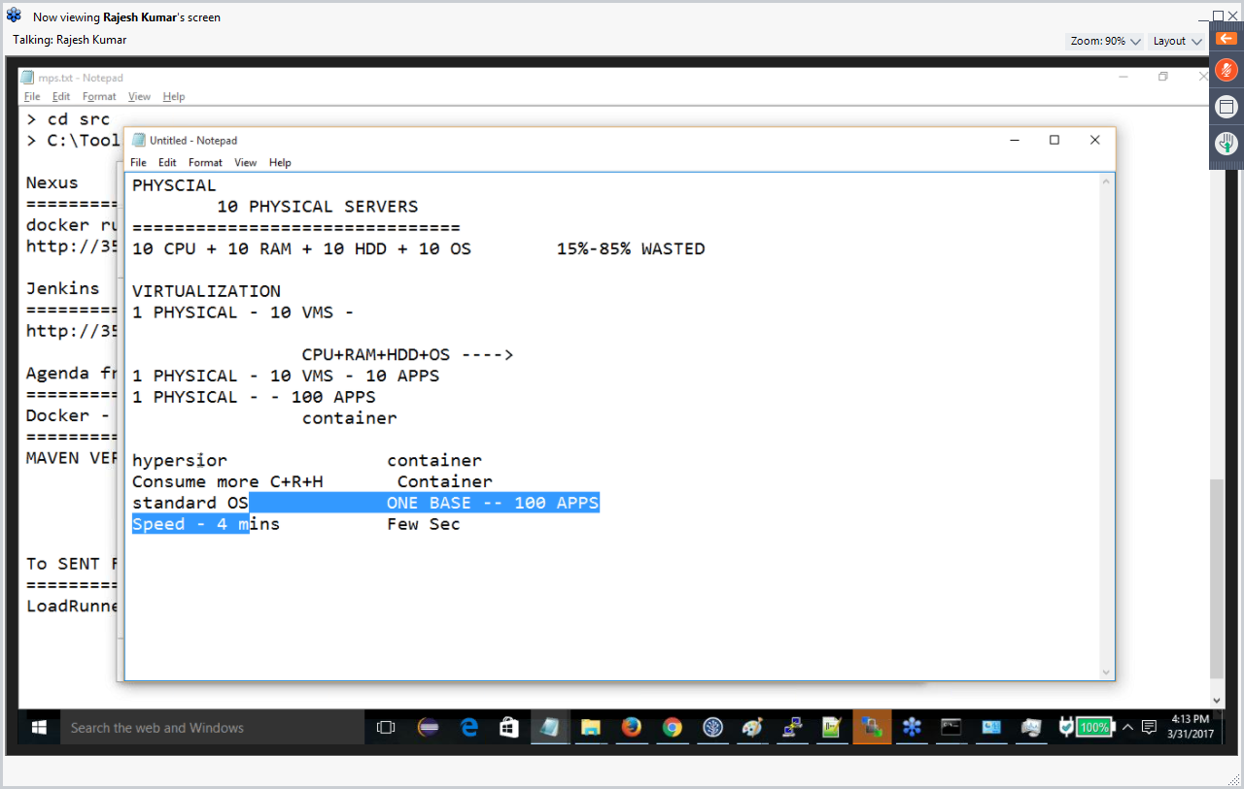

Docker is going to minimize the wastage of resources

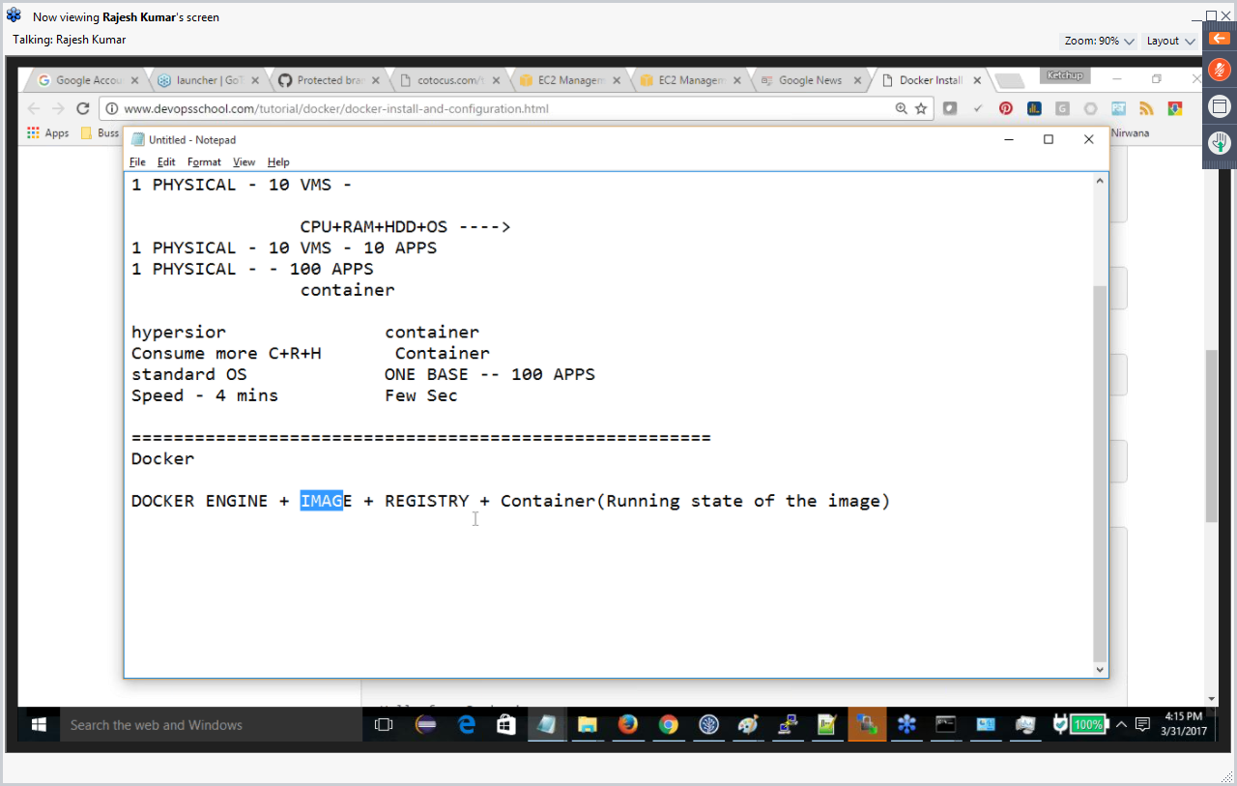

<https://Hub.docker.com> : All images are available.

Docker images

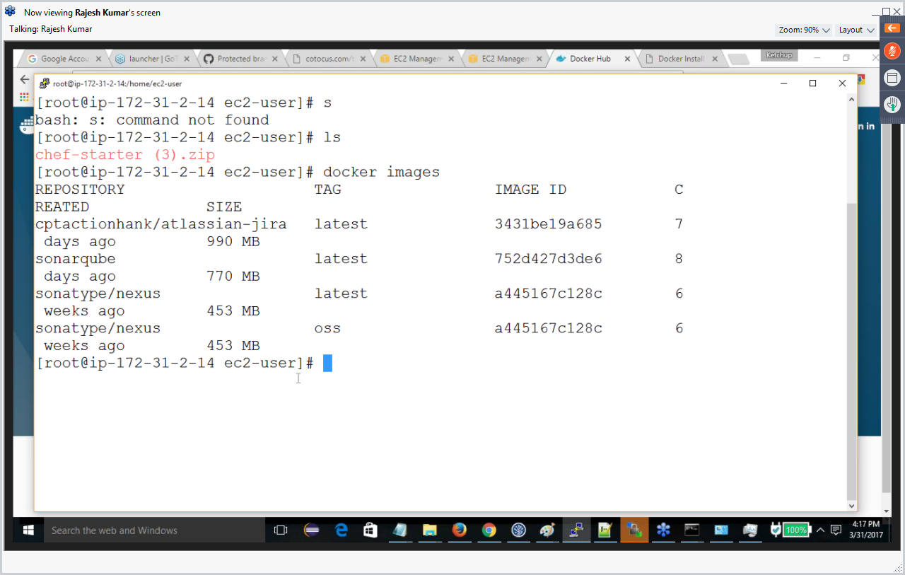

$docker ps

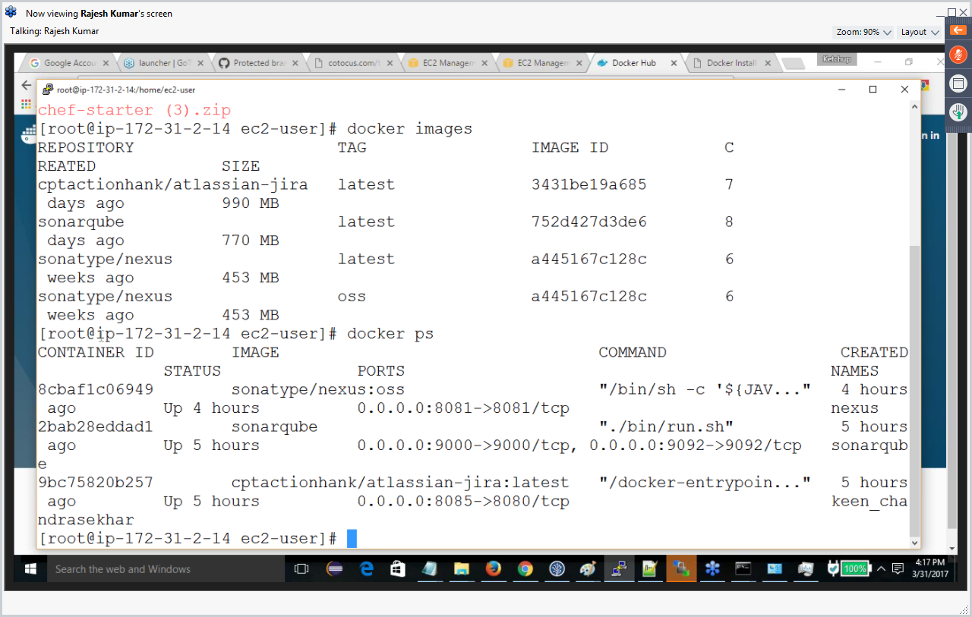

From one image we can install in as many containers. This saves lot of license. Just change the port.

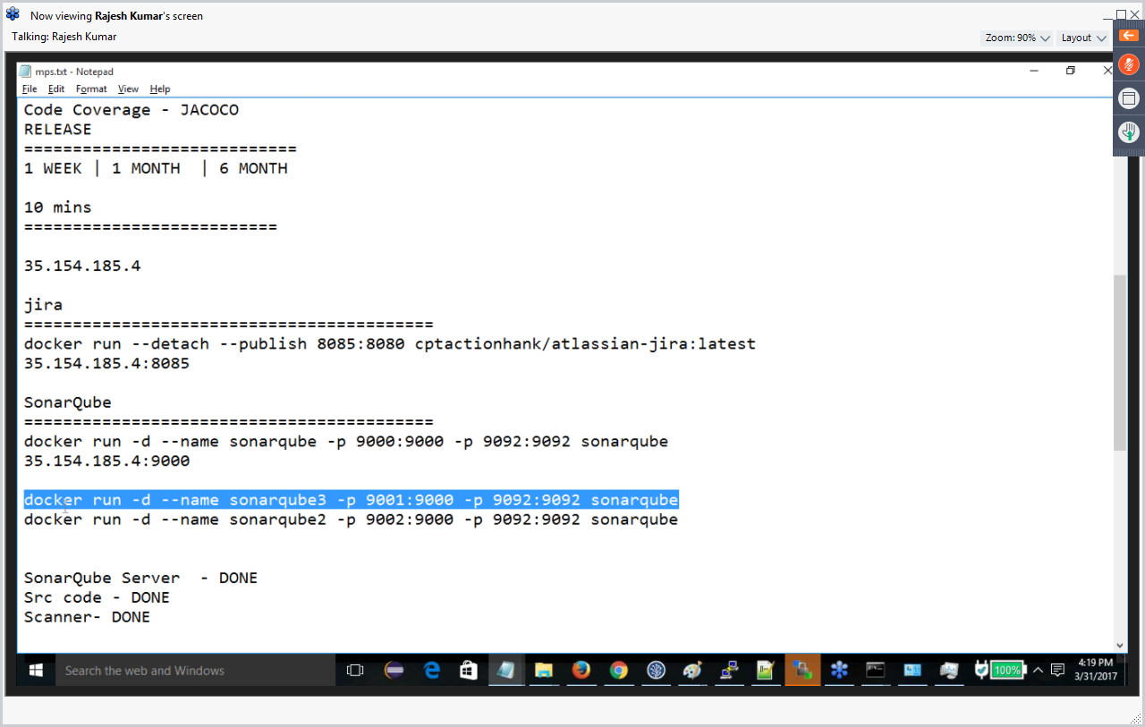

9004 – Extenal port

9000 is internal port

9096 is for scanner (External)

9092 is for scanner (Internal)

Docker rm <container id>

Docker stop <container id>

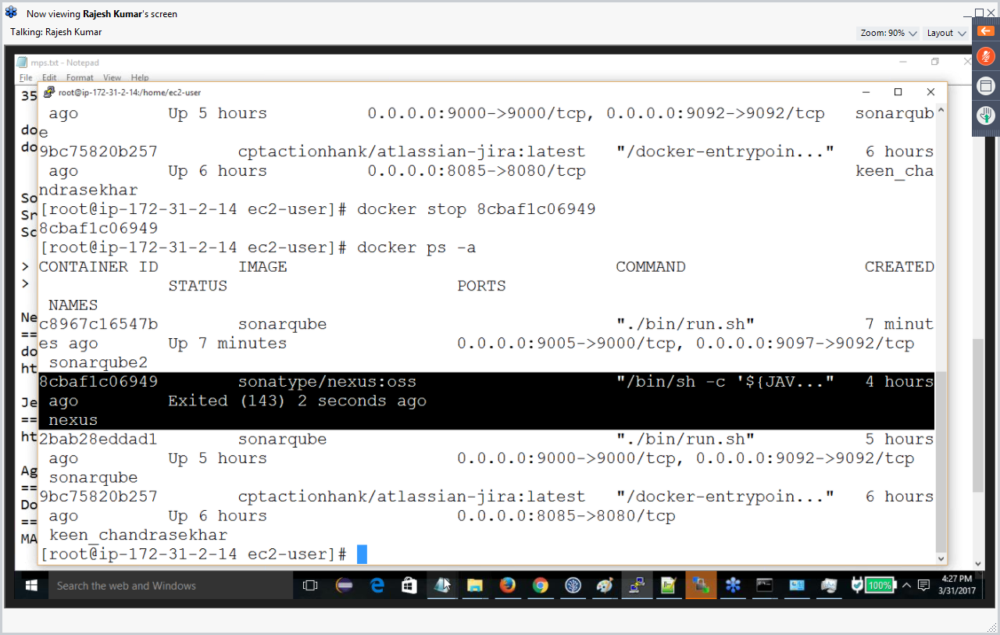

$docker start <container id> (start the Exited one)

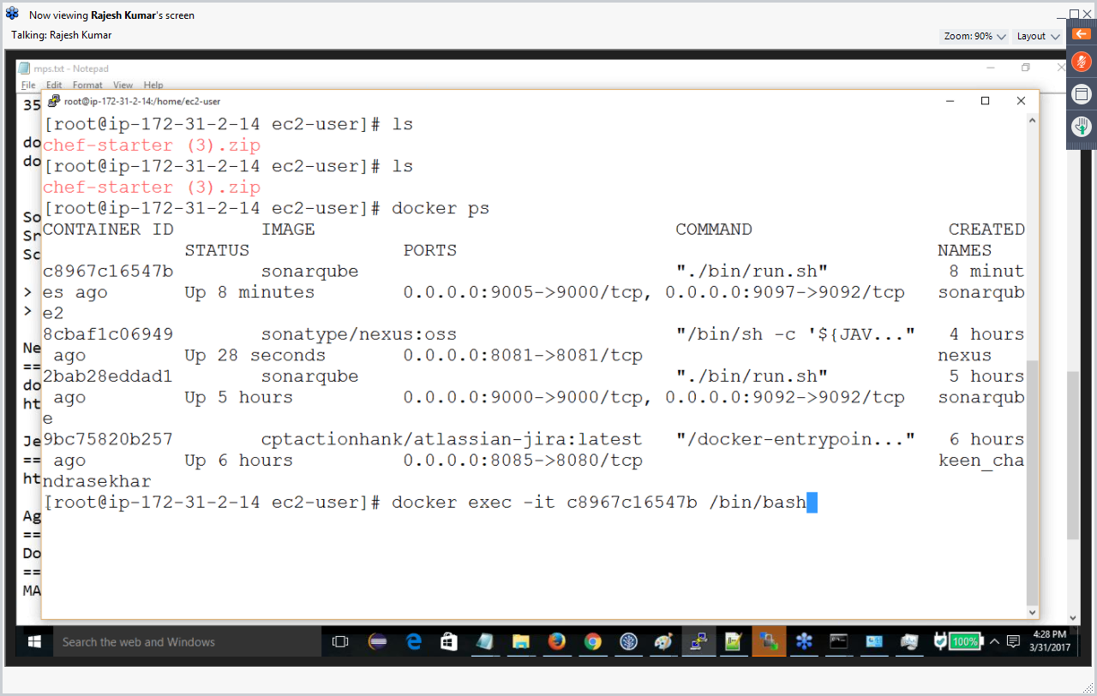

$Docker history <imageid>

$Docker info

Docker rm